Name: Jacob Braatz

Student ID: jbraatz  
Date: 12/1/2025

**Instructions:** Congratulations, you made it to the end of the course! Use the following to have a written discussion about your experience in the course and the final project. After you answer the questions below, insert a screenshot of each of the pages you have completed so far (remember, you should have at least 4 and the CSS file). Do NOT screenshot the html code because we can’t run the code. Save the file to yourasurite – Project – Assignment 5.docx file and yourasurite – Project – Assignment 5.pdf file.

**Before submitting this document and all your project files, make sure you meet all of these requirements listed in the CIS300 Project Instructions.pdf file.**

**Discussion Questions**

1. **Now that you are finished with your project, your original concept of your project might have changed a lot. Discuss in detail the differences between your initial project design and your final product. Why did you make these changes (if you had any)? (5 points)**  
   I did not make many changes from my original concept. I adjusted my wire frame a fair bit as I worked through creating the pages. Being able to implement and adjust I found a format that I preferred.
2. **Describe in detail why you chose the design layout you did. Are you happy with the outcome? Did you run into any issues with your design while developing your site? What did you do to overcome those issues? Would you do anything differently the next time you designed a website? (5 points)**  
   I chose the design layout by looking at other websites for similar businesses to my fictitious one. I’m happy with the outcome. I had some issues establishing and styling a side bar for my pages. I was able to check the course work and ai tools to help me understand and adjust. The main thing I’d adjust the next time I design a website is to put more time into styling based on display size. We did that in some of the course work, but it wasn’t a requirement for this project, so I didn’t put too much time into it.
3. **You likely encountered challenges while working on your final project. In detail, describe the challenges you encountered and what you did to overcome them. (5 points)**  
   I didn’t encounter many challenges while working on my final project. The case study work prepared me to create my own project. The only notable one was I had an issue figuring how to link my email address button without using mail. I ended up making it so that upon clicking the email hyperlink it copies the information to your clipboard and notifies you as an alternative.
4. **Describe several concepts that you learned during this course that you found interesting and useful. Where there any concepts that you wish more time was spent on? Is there anything you would have like to incorporate into your final project that wasn’t covered during this course? (5 points)**

I started this course with no coding literacy. Nearly all of the concepts were interesting and useful. Working though the html5 tags including header, footer, nav, div, really all of them were new to me. Also, the concept of adjusting the styling to match different display resolutions was interesting. I hadn’t really given it much thought before as a user that many sites adjust not just with mobile format, but also with other resizing. There are no other concepts I know of that I wish we spent time on or would’ve liked to incorporate into my final project.

1. **List your project website's GitHub URL. (3 points)**

https://jbraatz96.github.io/Project-Assignment/services.html

1. **Insert your website’s Google Analytics Realtime Overview Screenshot below (10 points)**

I couldn’t find this on the project instructions as deliverable or on the canvas assignment page. I am unable to provide this. Maybe I missed it, but if not it should be made more clear.

1. **While trying to be as objective and unbiased as possible, please go through and critique your own site using the attached rubric. In the student critique column, indicate which score you should receive for each category (outstanding, average, or needs improvement) and write a short (1 or two sentence max) justification of that score. (5 points)**

**Student Critique**

|  |  |  |  |  |
| --- | --- | --- | --- | --- |
|  | **Outstanding** | **Average** | **Needs Improvement** | **Student Critique** |
| **EXAMPLE** | You did everything! | You did a few things. | You did nothing… | Outstanding – I believe I did everything correctly because of x, y, and z. |
| **Visual Appeal** | Use of color, contrast, text, graphics is appealing to target audience | Appealing to target audience in all but one area. | Not appealing to target audience in more than one area | Outstanding: I used contrasting colors for my backgrounds and text, along with graphics relevant to the subject matter. |
| **Navigation** | Easy to use, consistent | Inconsistent or difficult to use | Missing | Outstanding: Site is very easy to use. Each page can navigate to any of the others. |
| **Page Titles/ Logo Area** | Descriptive and include the site/company name | -- | Missing or does not include the site/company name | Outstanding: Each page has the companies name which is also a link to nav back to the home page. |
| **Table** | Present and correct syntax | -- | Missing or incorrect syntax | Outstanding: Table configured with header row, three rows, three columns. |
| **Video** | Present and correct syntax | -- | Missing or incorrect syntax | Outstanding: Video present not using iframes to embed. |
| **E-mail Link** | Present and correct syntax | -- | Missing or incorrect syntax | Needs Improvement: had an issue with this noted above. |
| **Outside Link** | Present and correct syntax | -- | Missing or incorrect syntax | Outstanding: Running footer has 3 hyperlinks directing to asu.edu |
| **Meta tag** | Correct syntax (description meta tags), excellent selection of keywords and meaningful description | Correct syntax (description meta tags), adequate selection of keywords and description | Missing or incorrect syntax | Outstanding: Included meta tags and keywords for each page. |
| **Form Coding** | Contains 4 or more form fields, correct syntax, and meaningful form element names | Does not contain the required 4 form fields, incorrect syntax, or names of fields don’t make sense. | Missing | Outstanding: Created a contact form with 4 or more fields relevant to the site content. |
| **Form Processing** | Form uses # as the action. | -- | Form not configured correctly. | Outstanding: My form uses # as the action. |

**Web page browser view screenshot of Home Page**

**This page includes 0 video, 1 form, 0 table, 1 email, or 3 external links.**

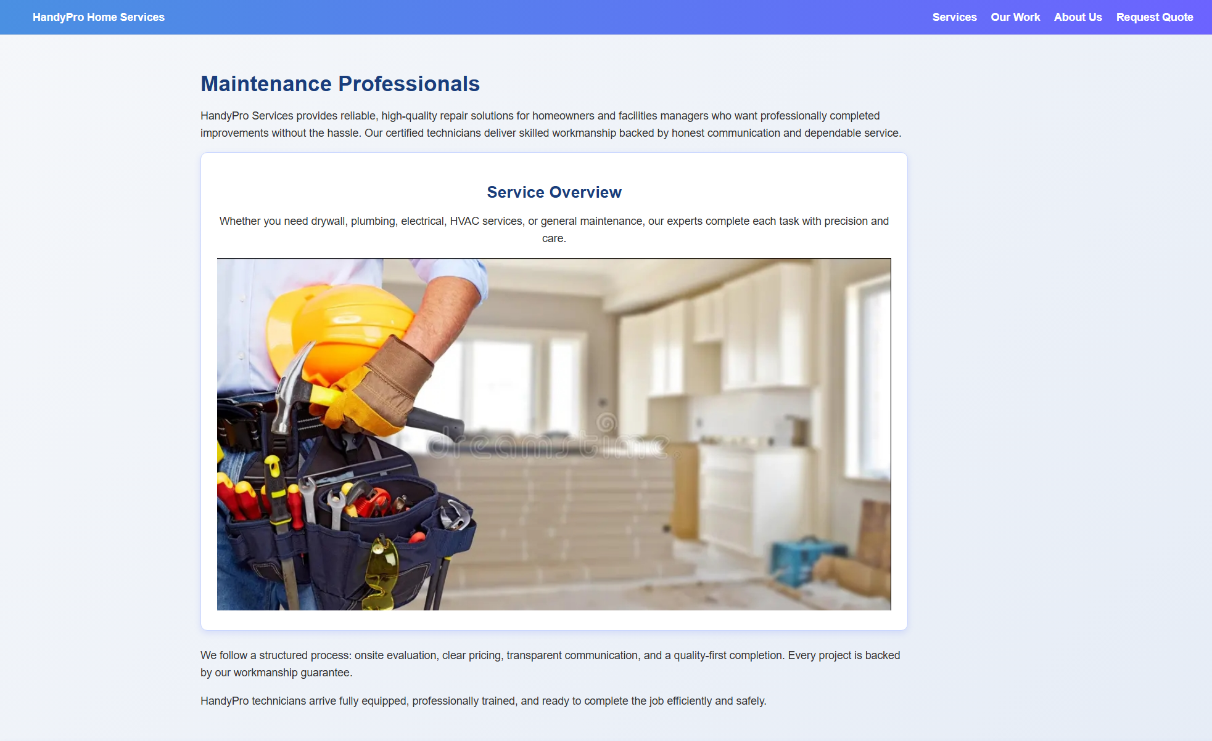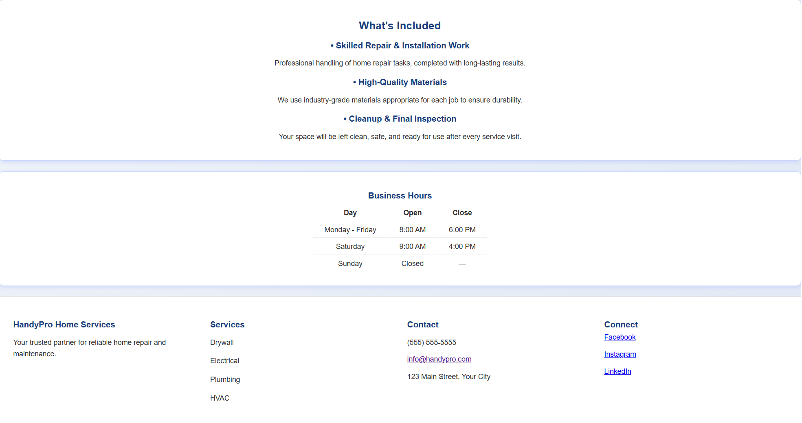

**Web page browser view screenshot of Page #1**

**This page includes 0 video, 0 form, 0 table, 1 email, or 3 external links.**

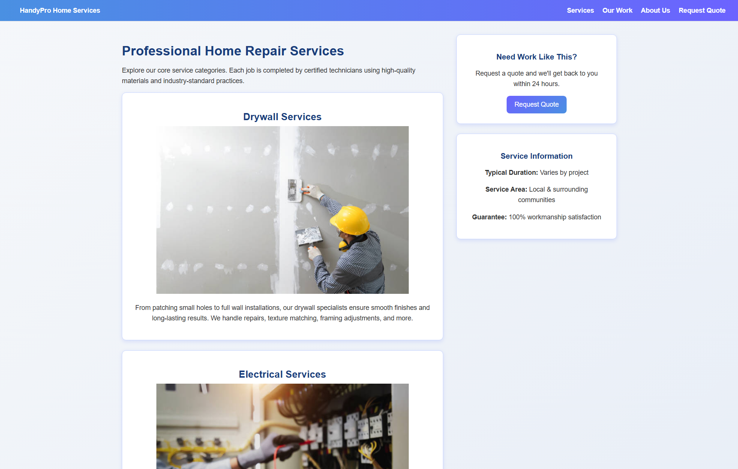



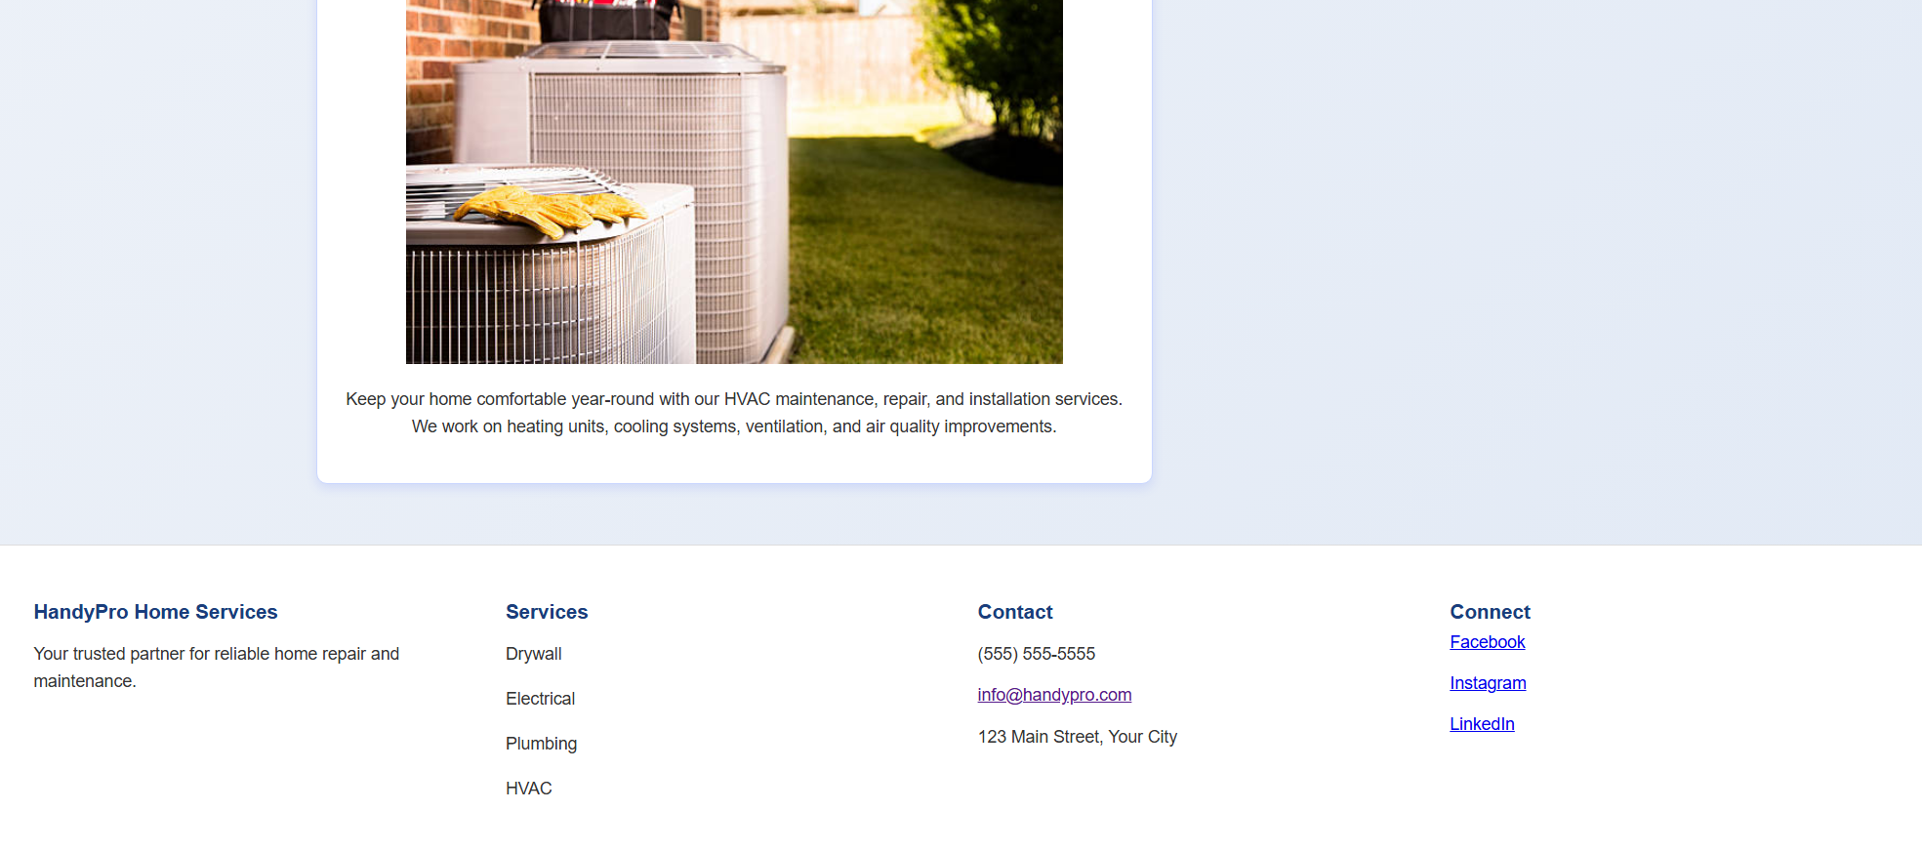

**Web page browser view screenshot of Page #2**

**This page includes 0 video, 0 form, 0 table, 1 email, or 3 external links.**

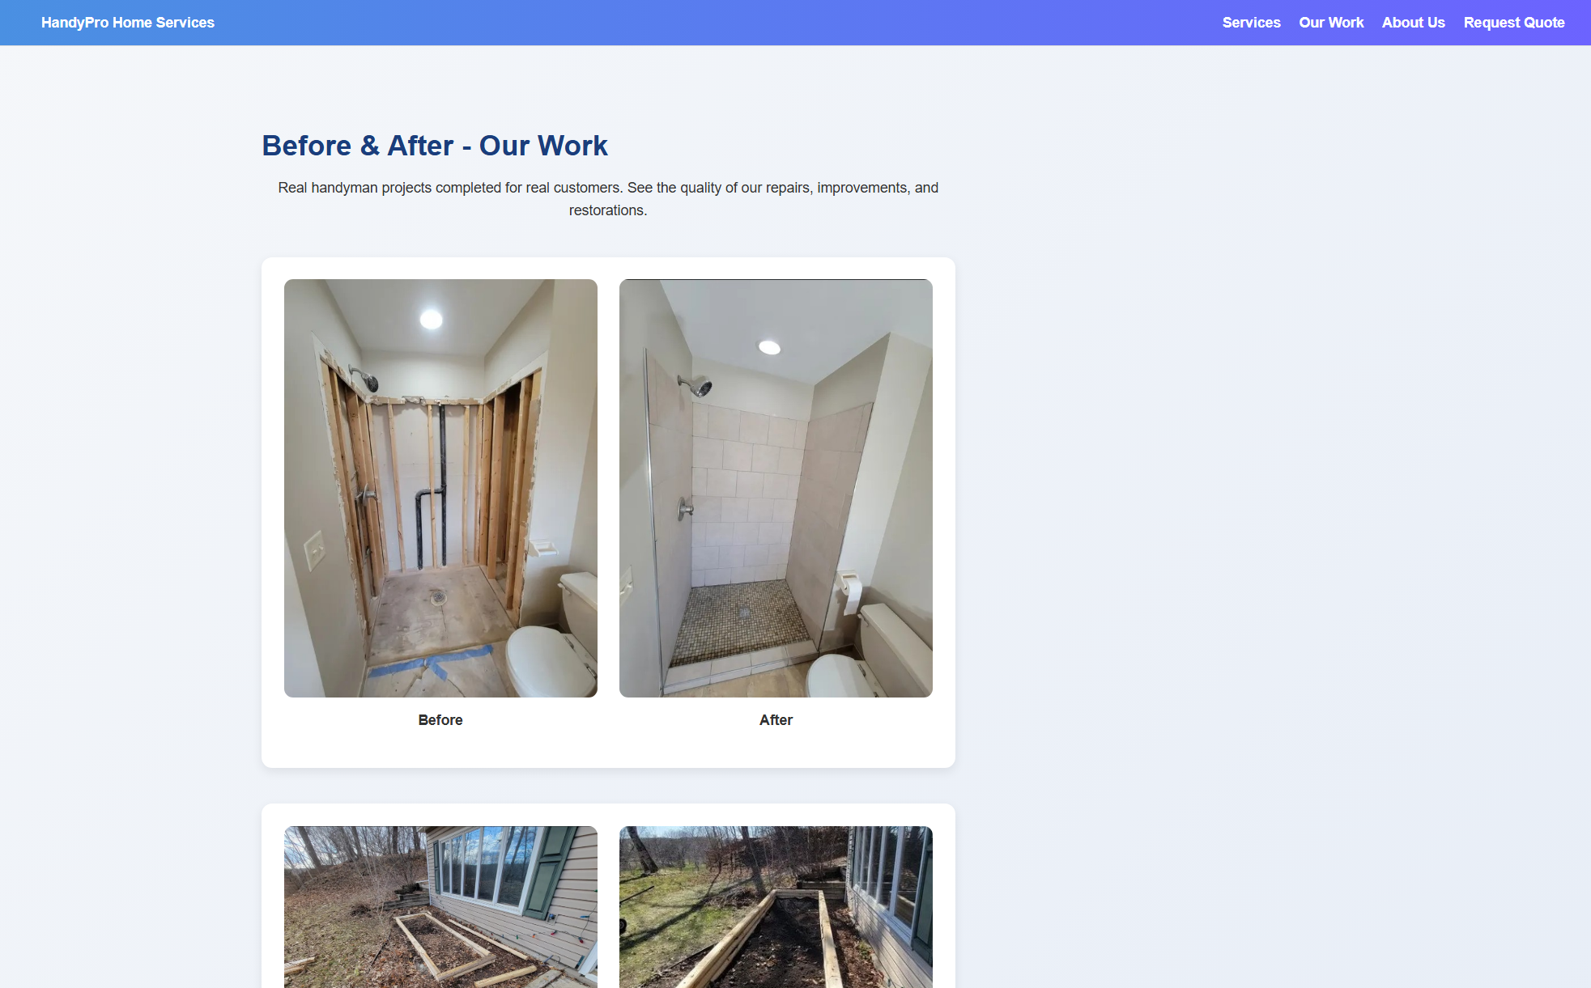

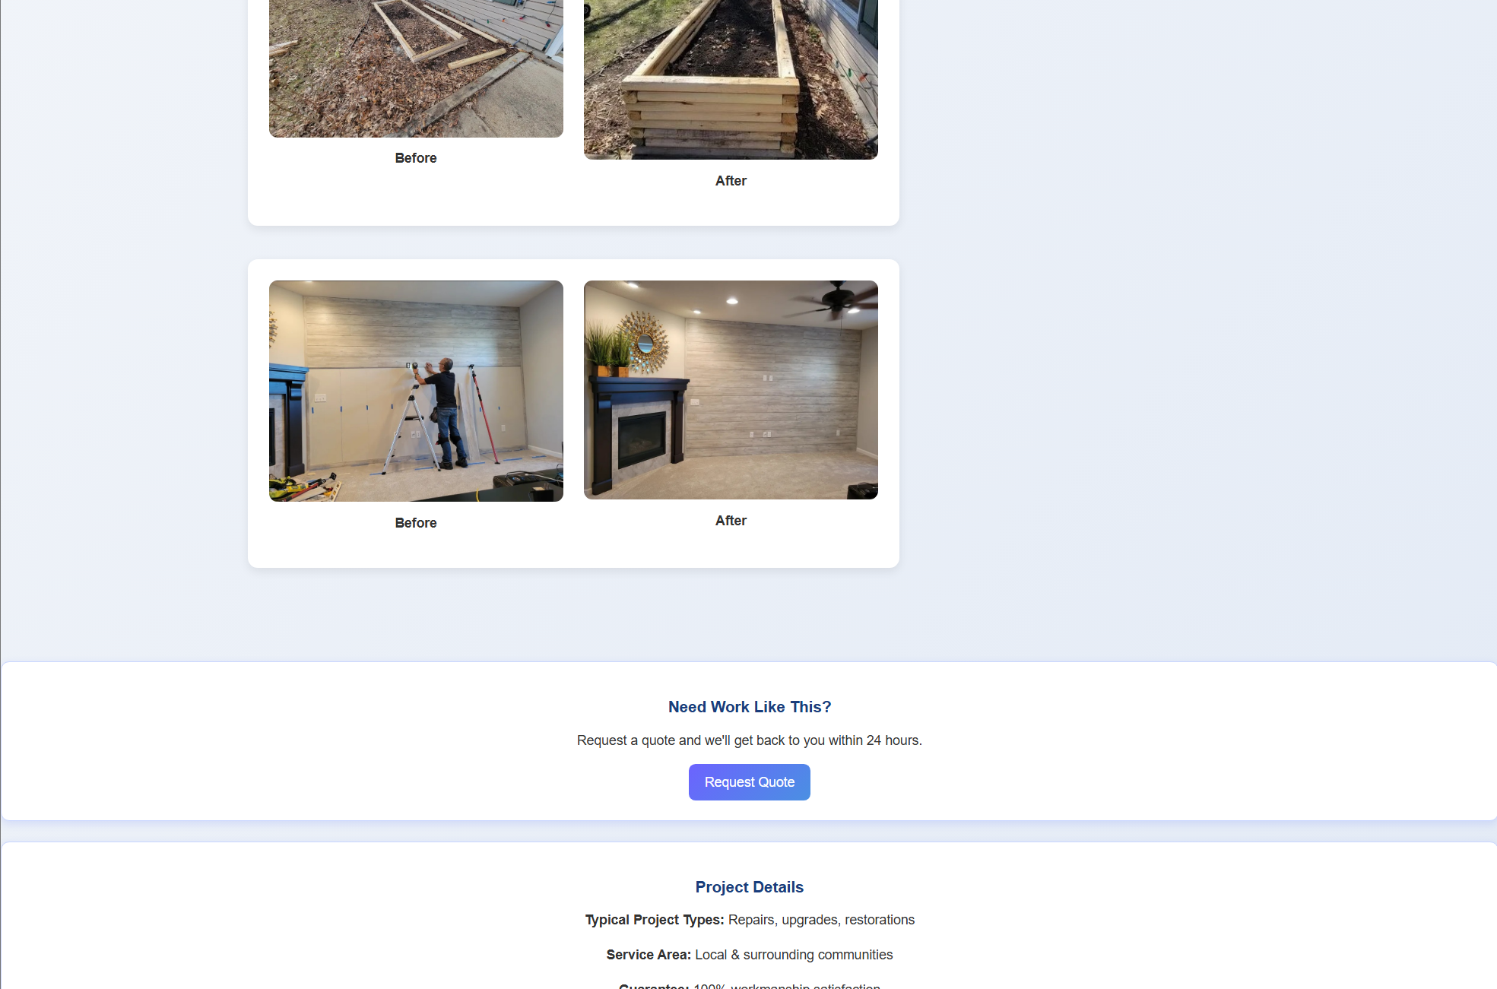

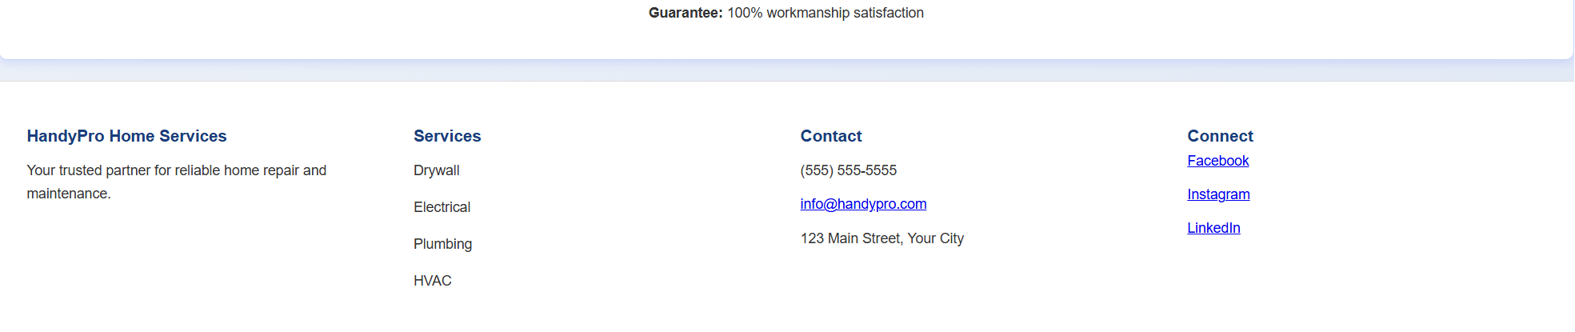

**Web page browser view screenshot of Page #3**

**This page includes 1 video, 0 form, 0 table, 1 email, or 3 external links.**

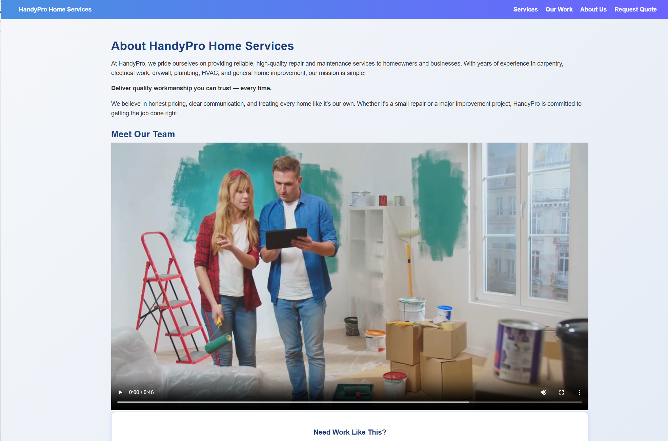

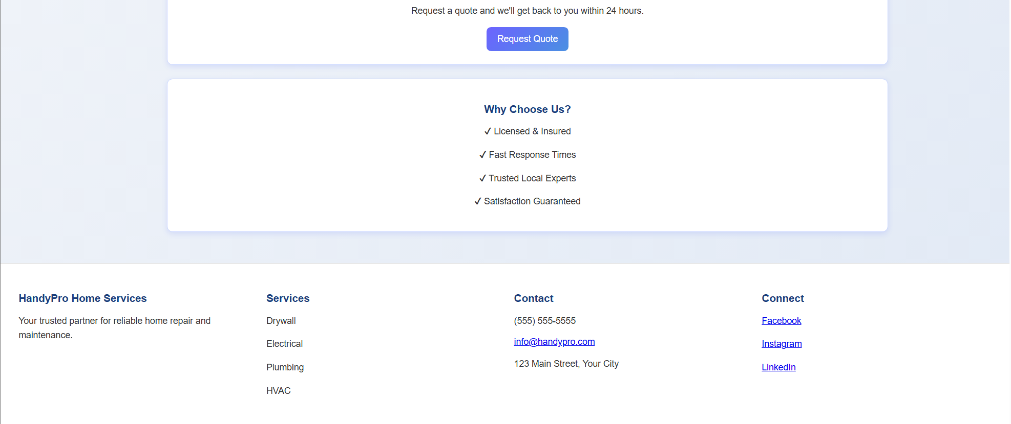

**Web page browser view screenshot of Page #4 (if it available)**

**This page includes 0 video, 0 form, 1 table, 1 email, or 3 external links.**

